

Final Project – NFL Relocation Recommendation

Bronsin Jabraeili, Nicholas Johnson, Marco Khalil
MSDS 457 – Sports Management Analytics
Dr. Bradley Smith
November 28, 2023

Executive Summary
This report and the analyses therein set out to answer a key question facing the National Football League (NFL): how does the league ensure its long-term success as well as the success of its 32 teams? More specifically, this report investigates the health of each NFL franchise with the intention of recommending one team for relocation. Through a variety of data-driven analyses, each NFL team is assessed and compared for which would most benefit from the proposed relocation. These analyses include a variety of exploratory data analysis (EDA) methodologies, team segmentation via unsupervised learning, the definition and compilation of data-driven “relocation” scores, and linear programming optimization models. This holistic approach, wherein a variety of analyses determine the optimal relocation candidates, removes bias from the decision process and considers perspectives crucial to key stakeholders, such as team owners. An analysis as subjective and challenging to quantify as relocation can be simplified and assessed in a data-driven manner, offering guidance to the NFL to optimize its portfolio of markets in which the teams compete.
These analyses provided impactful, data-driven insights which identify the NFL team most in need of relocation. The EDA and segmentation components of the analyses aided in the initial identification of relevant factors and teams to investigate, while the “relocation scores” and optimization model further focused our team’s efforts in identifying the most appropriate relocation candidate. After substantial data aggregation, data wrangling, and analysis based on a variety of factors (team revenue, team winning history, and social media engagement), we identified the Jacksonville Jaguars as the NFL franchise that would most benefit from a relocation. Additional detail on data, analyses, findings, and recommendations are included in this report.
Introduction
The NFL is comprised of 32 teams, each striving for success on the field as well as maximizing team and league revenue for their stakeholders. As a result, continuous assessment of potential opportunities is crucial for generating greater cash flow. One strategy to achieve this objective involves contemplating the relocation of underperforming teams to emerging markets that could better support the team. However, the complexity of this topic extends beyond financial considerations alone, requiring a comprehensive analysis that delves into the mindset of team owners. Factors to be considered include the strength of potential sponsorships in the new market, consistent fan attendance, the team's financial viability, the impact on the city if the team departs, and other risks associated with relocation.
Despite the intricate and contentious nature of sports-related relocations, such moves have been prevalent in the history of professional sports, contributing to expansion and increased popularity by leaving less lucrative markets for more promising ones. To navigate the complexity and uncertainty inherent in this topic, leveraging analytics becomes paramount. The perspective of this research assignment is to work as analytics consultants for the NFL, providing recommendations on teams that should be considered for relocation.
While this analysis can be relatively subjective, the use of robust analytical frameworks allows for objective insights to inform optimal decision-making. Multiple approaches are employed to gather diverse perspectives on which teams merit relocation consideration. Following the assessment of outputs and the identification of potential optimal candidates, a comparative analysis between organizations helps pinpoint the primary contender for relocation. It's essential to note that these insights are recommendations based on available data, allowing subject matter experts, the decision-makers, to make informed choices. Analytics expedites the decision-making process while minimizing bias, providing a data-driven foundation for strategic moves in the dynamic landscape of professional sports.

Literature Review
Numerous academic works have addressed key considerations for NFL relocation, with a predominant focus on qualitative aspects and business considerations. Fortunately, these articles appear to align with the categories identified as crucial for the financial health of NFL teams in this research assignment. For example, Fisher et al. states “The NFL also has a procompetitive interest in where its teams are located. The financial success of the League is dependent on developing and retaining fan interest. This, in turn, is dependent on maintaining geographic diversity and franchise stability.” This is inline with the assumptions that market analysis is key to the financial success of these teams. The consideration of franchise stability is also important because teams that have historic rivals can leverage those rivalries to drive fan engagement and be less likely to relocate.
Unfortunately, a specific exploration of academic sources utilizing data science for NFL relocation yielded no results. While there is an abundance of articles covering game prediction, simulations, and various essential considerations related to the NFL games, surprisingly no sources were found that provide code or mathematical representations to address relocation analysis. This lack of tangible code and statistical guidance does not hinder our research. As long as the other articles confirm assumptions and thought processes implemented in the project formulation, the coding and mathematical frameworks can be established by the researchers. It is vital that the academic community emphasize the publishing of written code so future researchers have access to the scripts when performing a similar analysis, building out further analyses with each iteration.

Methods
Data Acquisition
To ensure a comprehensive analysis, a wide range of data was gathered, prioritizing information from reputable and reliable sources. In this instance, Statista served as the primary trustworthy data source. Various metrics were collected including Revenue, Valuation, Stadium Capacity, Average Ticket Sales, Number of Twitter Followers, and All-Time Win Percentage. The data obtained from Statista underwent a rigorous cross-comparison with other reliable sources to validate its accuracy. For example, Forbes exhibited identical numbers to those found in the Statista dataset. This cross-referencing or "sanity check" instills confidence in the findings of the report, emphasizing that the quality of the analysis is contingent upon the quality of the data. By meticulously ensuring consistency among diverse sources, the report maintains a complete and robust foundation for its conclusions.

Data Wrangling
The collected data is already high-quality and structured well, requiring minimal data wrangling. Each metric was stored in a separate Excel file (.xlsx) and imported into a data frame using the Pandas library in Python. Subsequently, a sequence of merges was executed, utilizing the NFL team name as the key, until all individual data frames containing metric-specific data were consolidated into a single master data frame. At this point the data was prepared for all analyses within this research assignment.
K-Means Clustering Methodology
Following the acquisition and wrangling of the relevant data, it was time to begin the identification process for a potential relocating team. As a starting point K-Means Clustering, an unsupervised learning algorithm, was used to segment the data. The data used for this portion included Revenue, Average Ticket Price, Team Valuation, All-Time Win Percentage, Number of Twitter Followers, and Stadium Capacity. This algorithm sorted the teams into groupings based on shared characteristics (e.g., teams with high revenue, high ticket prices, and low Twitter followers would potentially appear in the same cluster). The intended outcome of this analysis was to identify a grouping of teams that tended to perform worse across our metrics of interest. The resulting “low performer” cluster(s) would serve as a starting point for subsequent analyses into relocate candidates. Results are shown on page 12.

Relocation Score Methodology
One of the most intuitive and versatile methods to quantify and assess the suitability of an NFL team for relocation is to formulate a proprietary "relocation score." The first step in creating such a score involves determining the weight assigned to each metric (totaling 100%). The weights assigned to all metrics in the dataset are detailed in Table A below.
Metric | Weight
Revenue Value (in $M) (RV) | 0.30
Valuation (in $B) (V) | 0.30
Average Ticket Price (in $) (ATP) | 0.20
Number of Twitter Followers (in M) (NTF) | 0.10
All Time Win % (ATW) | 0.10
Table A - Relocation Score Weightage
Note that Stadium Capacity was excluded from this metric. This omission is due to the rapid changes in stadium infrastructure, with teams like the Washington Commanders and Chicago Bears slated for substantial upgrades. Including Stadium Capacity in the formula would have disadvantaged teams like the Chicago Bears, an iconic NFL franchise with a rich history and a significant presence in one of the largest media markets. Despite potentially scoring lower in the relocation score, the Chicago Bears are considered an untouchable team, given their popularity and consistent support from fans nationwide. The rationale for each weight assignment lies in the predominant consideration for relocation, often viewed through a financial lens. The decision to stay or relocate is typically driven by the option offering the most promising future financial prospects. Consequently, Revenue and Valuation received larger weights compared to other metrics. Ticket sales were accorded a slightly higher weight as they serve as a proxy for both consumer demand and the economic market conditions of the city in which a team plays. While the popularity of a team and its on-field performance are significant considerations, success in terms of business outcomes can be achieved independently of on-field and online success. Prioritizing financial health and business outcomes represents a conservative and realistic approach in feature engineering the relocation score, placing the importance on stakeholder interests. Once the assumptions for the relocation score have been established, the computation is straightforward. This involves a simple calculation, summing each data point multiplied by its assigned weight. The formula is as follows with respective metrics abbreviated:
$$0.3RV+0.3V+0.2ATP+0.1NTF+0.1ATW=Relocation Score$$
Once the score is calculated for each NFL team, the data frame can be sorted in descending order and the teams with the lowest scores can be considered to be relocation candidates. Results can be seen on page 13.

Optimization Modeling Methodology
As highlighted in the introduction, it is vital to these analyses to account for the constraints that NFL franchise owners would consider in the sensitive decision of relocating a team to a new city. Optimization modeling can replicate the perspective, considerations, and constraints faced by the NFL in evaluating relocation options. The three key components of the optimization model are the decision variables, objective function, and constraints. Beginning with the decision variables, there are 32 NFL teams, each regarded as a candidate for relocation.
Hence, 32 decision variables were established to signify whether a team should be considered the top candidate for relocation. In this scenario, the decision variables are binary, where 31 teams receive a 0, indicating they are not considered for relocation, and 1 team receives a 1, designating them as the recommended team for relocation. For the objective function, the primary focus for teams is financial, and thus the optimization model centers around maximizing revenue. Revenue coefficients for each NFL team were established and associated with the decision variables.
The last considerations lie in defining constraints. A rational threshold must be set, determined to be the median for all metrics (Revenue, Valuation, Stadium Capacity, Average Ticket Sales, Number of Twitter Followers, and All-Time Win Percentage). For each metric, the constraint aims to select teams that are less than or equal to the median, allowing for a holistic selection that considers teams that may be subpar in various categories. Additionally, there is a constraint to ensure only one team is selected for relocation. While multiple teams could have been chosen, the goal of this analysis is to be more specific compared to the K-Means Clustering and Relocation Score analyses. These results can be seen on page 14.

Results
Exploratory Data Analysis
The initial step in this project involved conducting exploratory data analysis to uncover potential patterns. The primary analysis consisted of constructing a correlation matrix to identify relationships between the collected metrics. The output results are presented below, indicating the highest correlation is between the Revenue and Valuation metrics.
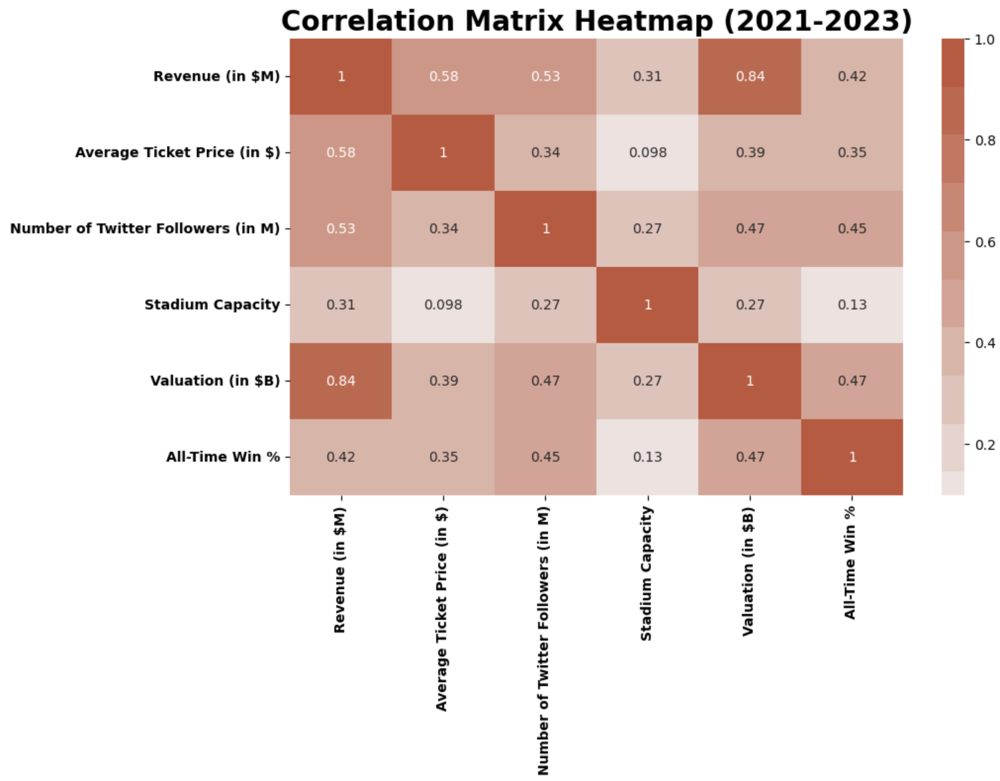
Exhibit A - Correlation Matrix
The next analysis was to see the relationship between the Average Ticket Prices that teams are charging and how it relates to Revenue. Exhibit B below shows the output results.
Unsurprisingly, a robust correlation exists between the revenue generated and the overall valuation of a team. Revenue also exhibits a moderate positive correlation with the Average Ticket Price, Number of Twitter Followers, and All-Time Win Percentage. To a lesser extent, Stadium Capacity shows a slight correlation, but this is logical as the availability of seats does not guarantee their occupancy. Overall, these findings confirm suspicions that factors such as a strong social media presence, on-field performance, and pricing strategies impact revenue to varying degrees. The subsequent analysis aimed to explore the relationship between the average ticket prices charged by teams and their corresponding revenue generation. Exhibit B below displays the output results.
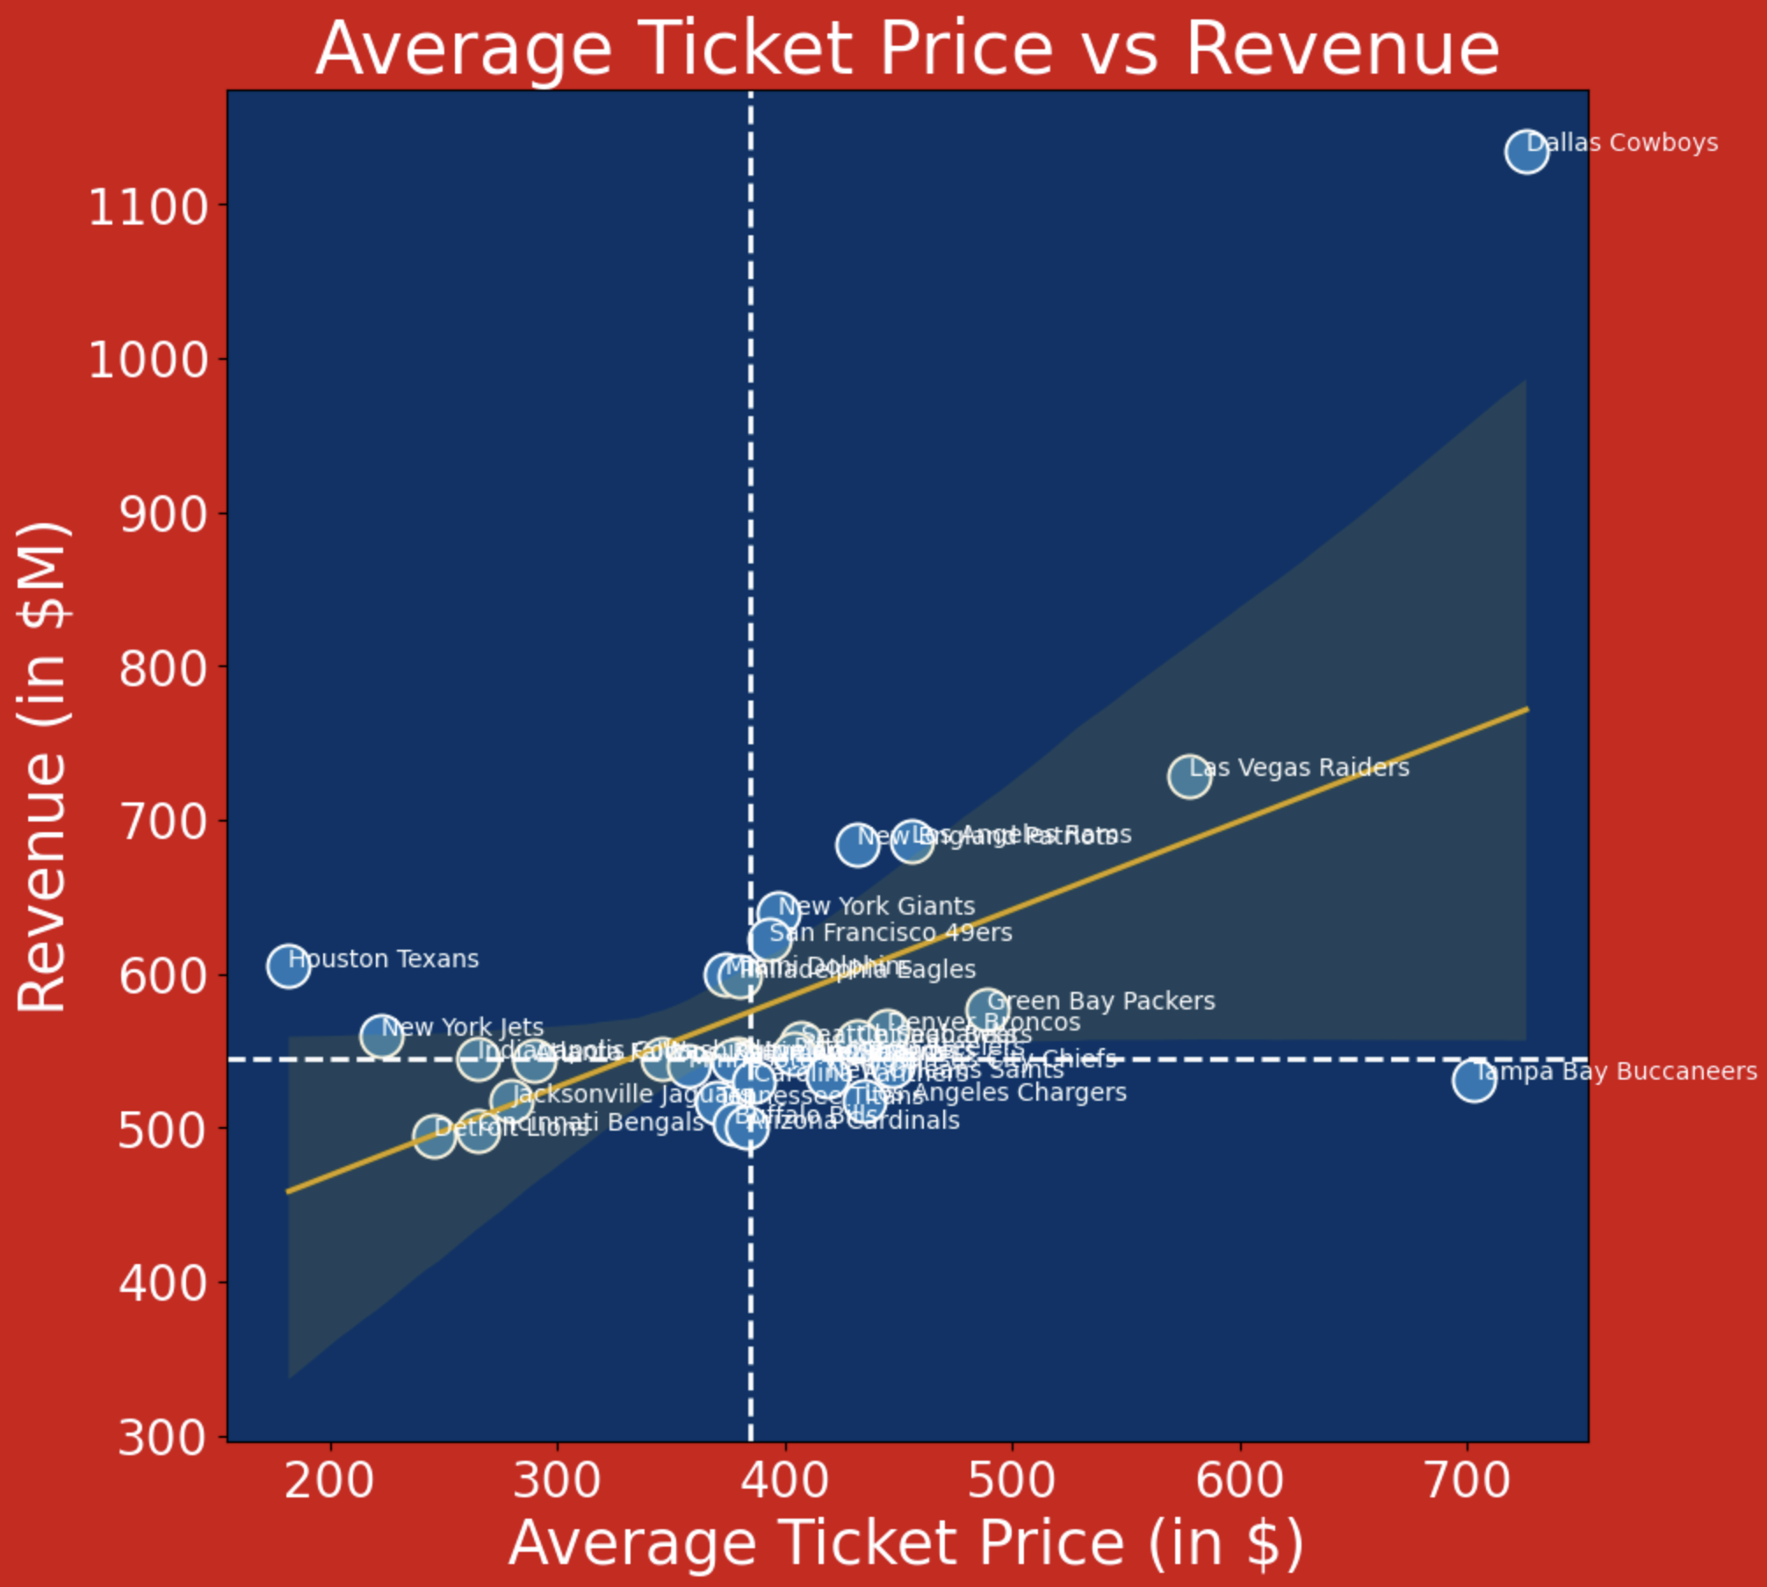
Exhibit B - Scatter Plot (Revenue vs Average Ticket Price)
This illustrates which teams generate revenue by charging higher average ticket prices, and there is a positive correlation between these two metrics. A select group of teams, including the Detroit Lions, Cincinnati Bengals, and Jacksonville Jaguars, seems to fall below the average revenue generated and charges the lowest ticket prices. These are preliminary candidates suspected to be potential relocation possibilities.
When examining the correlation between social media popularity and the overall valuation of a franchise, five teams emerge as potential relocation candidates based on these metrics: the aforementioned three teams, along with the Buffalo Bills and Arizona Cardinals (Exhibit C).
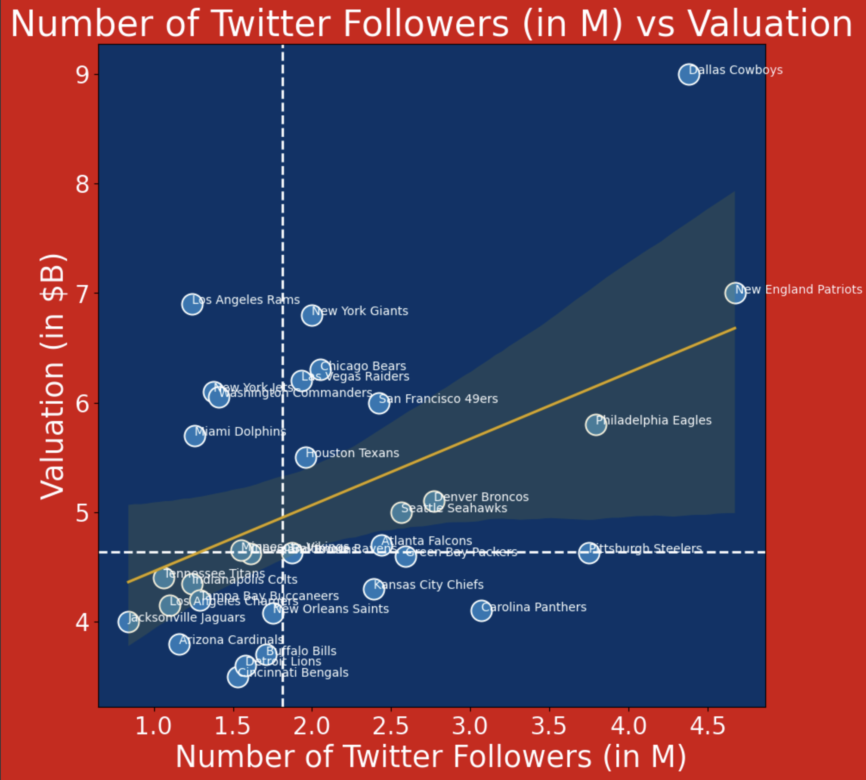
Exhibit C - Scatter Plot (Valuation vs Number of Twitter Followers)
Based solely on the initial exploratory data analysis, a handful of teams stand out as probable candidates for relocation as they consistently appear in the lower performing section for each of the analyses. The remaining results will either affirm or refute these preliminary findings.

K-Means Clustering Results
The purpose of the K-Means Clustering analysis is to narrow down the full population of 32 teams into more manageable groupings of less successful teams, which the algorithm did successfully. The clustering algorithm segmented the NFL teams into four groups. As is typical with clustering, analysis of the results is required to tell the full story of the resulting output. To achieve this, summary statistics for each segment were output and investigated.
The first cluster of interest, Cluster 0, contained some of the marquee, big market franchises in the NFL, namely the Dallas Cowboys, Green Bay Packers, New York Giants, and New York Jets. This cluster of teams boasted by far the highest average Revenue, Average Ticket Price, Team Valuation, All-time Win Percentage, Number of Twitter Followers, and Stadium Capacities of the resulting clusters. Cluster 0 firmly defined a subset of teams that would not be considered for relocation, given their elite metrics across the board.
The second cluster of interest, Cluster 3, contained several smaller-market yet popular and successful teams. Cluster 3 contained the Denver Broncos, Kansas City Chiefs, New Orleans Saints, and the Carolina Panthers. These teams fell lower on the Revenue and Team Valuation metrics but quite high with respect to Average Ticket Price, All-time Win Percentage, Stadium Capacity, and especially Number of Twitter Followers – these teams very closely matched the premier, big market Cluster 0 teams with respect to Twitter followers (e.g., 2.6M average followers for Cluster 0 and 2.5M average followers for Cluster 3). Given these results, the Cluster 3 teams were also removed from relocation consideration, as these successful small-market teams showed signs of strong organizational health.
The final two clusters, Cluster 1 and Cluster 2, represented the remaining 24 NFL teams who are relatively less successful as measured by this analysis. These clusters exhibited several differences from one another, but had generally worse metrics across the board as compared to Clusters 0 and 3. These clusters contained teams with the lowest Average Ticket Prices, lowest All-time Win Percentages (e.g., both had percentages slightly below 50%), Number of Twitter Followers, and Stadium Capacities. As such, these were the subsets of teams that were identified as relatively less successful teams, per the specified metrics, and for whom a relocation would be more beneficial.

Relocation Score Results
The relocation score was constructed to determine which teams should be moved based on the weights assigned to each metric. The results of the code can be observed in the Appendix. Overall, this aggregate relocation score spanned from ~200-500 points, with a median score of ~244 points. This distribution of scores was heavily skewed rightwards, resulting in a small subset of teams with relatively high scores, and a higher distribution of teams receiving relatively low scores.
The top teams in this analysis include the Dallas Cowboys, Las Vegas Raiders, Tampa Bay Buccaneers, and Los Angeles Raiders. In comparison to the preceding analysis, with the exception of the New York Jets, three of the four teams belonging to the “marquee / big market” Cluster 0 appeared in the Top 7 of the relocation score metric, namely the aforementioned Dallas Cowboys, the New York Giants, and the Green Bay Packers.
Of particular interest to this report were the lowest-scoring NFL franchises, those most likely to benefit from relocation. There were six NFL teams that scored below 220: the Houston Texans, the Indianapolis Colts, the New York Jets, the Jacksonville Jaguars, the Cincinnati Bengals, and the Detroit Lions. Many of these teams have either been perennial losers in recent years or reside in smaller markets, so these results are not particularly surprising. Of these lowest-rated teams, the Detroit Lions were the only one to receive a score below 200. In comparing these lowest-scoring teams to the preceding cluster analysis, the New York Jets were bottom 4 in our relocation score but belonged to Cluster 0 with other high-performing teams, so they are not a good candidate for relocation. Based on these analyses alone, the five teams potentially most conducive to a move are the Texans, the Colts, the Jaguars, the Bengals, and the Lions.

Optimization Modeling Results
Based on the design of the optimization model and the constraints established regarding the median and single team selection, the result of the model will be 1 recommended team for relocation if there is a feasible solution. This model instance resulted in a feasible solution, the Jacksonville Jaguars. The Jaguars were a team observed to be a realistic candidate in the exploratory data analysis, K-Means Clustering, and was the third most likely candidate based on the Relocation Score. Qualitatively, the Jaguars are one of the newest NFL teams and they already play a couple of their home games overseas in London. Intuitively and based on the data-driven results of the model, it makes sense that the Jaguars would be one of, if not the top few candidates for relocation.

Conclusions
Final Recommendations
Now that a thorough and robust analysis has been completed, and several candidates have been identified, a recommendation can be made. Based on the various analyses, two teams stand out as optimal candidates for relocation: the Detroit Lions and the Jacksonville Jaguars. When comparing the revenue of these two teams over the past 20 years, Jacksonville has consistently surpassed Detroit, maintaining the lead for the past 15 years (refer to Exhibit D).

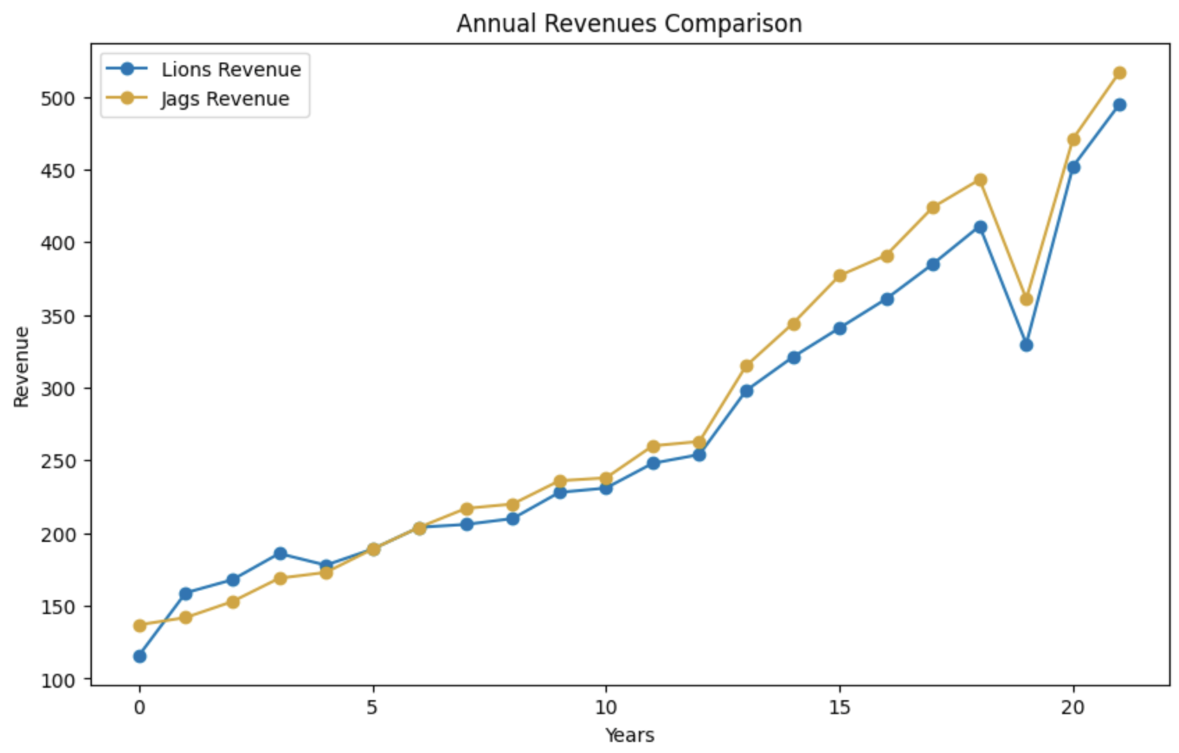
Exhibit D - Detroit Lions vs Jacksonville Jaguars Historical Revenue Comparison
Although the Lions have typically been generating less revenue than the Jaguars, it is necessary to also consider qualitative components when making this recommendation. The Detroit Lions, founded back in 1930, stand as one of the most historic franchises in NFL history being the 5th oldest team per Loodibee Logos. Despite not having won a championship since the AFL/NFL merger in 1970 and historically being perceived as perennial underachievers, they have the tradition of playing every Thanksgiving and are seen as an immovable team with robust support from their ownership group, the Ford family. In contrast, the Jaguars, entering the NFL in 1995, have never won the Super Bowl and share a history of consistent underperformance. They are often the subject of experimentation by the NFL, such as international games in London. Considering these factors, the final recommendation is to consider the Jacksonville Jaguars as the top candidate for any potential relocation scenarios.

Next Steps
In the next iteration of this research, a comprehensive analysis comparing the Detroit Lions and Jacksonville Jaguars will be conducted. This will include forward-looking revenue calculations to determine which team is poised for better growth post-relocation. Additionally, other key metrics will be collected and forecasted to assess whether the trends are positive, negative, or exhibit divergent patterns. Another valuable assessment will involve identifying strong market candidates to receive this relocated team. Gathering data on population, economic GDP, geographic location, and more will serve as vital metrics for determining the optimal new location. Some markets that come to mind include Toronto, Oklahoma City, and Salt Lake City. Key considerations will involve examining travel logistics and potential revenue streams. Survey data gauging public sentiment from potential new cities could be a significant catalyst in the decision-making process, helping determine if there will be ample support for a team to move there. Previous team relocations, such as the Los Angeles Rams (from St. Louis), Tennessee Titans (from Houston), and Las Vegas Raiders (from Oakland), could serve as valuable proxies. In essence, this approach will not only identify teams for potential relocation but also pinpoint the best destinations for such relocations within the NFL.

References
Fisher, Franklin M., Maxwell, Christopher, Schouten, Evan Sue (2000). The Economics of Sports Leagues and the Relocation of Teams: The Case of the St. Louis Rams. Marquette Sports Law Review https://scholarship.law.marquette.edu/cgi/viewcontent.cgi?article=1468&context=sportslaw
Harrison, C. Keith, and Scott Bukstein. “Analytics and Ticketing Innovations at the Orlando Magic.” In Sport Business Analytics: Using Data to Increase Revenue and Improve Operational Efficiency, 23-34. Boca Raton: CRC Press, Taylor & Francis Group, 2017.
Harrison, C. Keith, and Scott Bukstein. “Ticket Markets in Sport: Is the Secondary Market Becoming the Primary Market.” In Sport Business Analytics: Using Data to Increase Revenue and Improve Operational Efficiency, 35-52. Boca Raton: CRC Press, Taylor & Francis Group, 2017.
Harrison, C. Keith, and Scott Bukstein. “Market Research Analytics and Data-Driven Innovation.” In Sport Business Analytics: Using Data to Increase Revenue and Improve Operational Efficiency, 173-186. Boca Raton: CRC Press, Taylor & Francis Group, 2017
Miller, Thomas. 2015. Sports Analytics and Data Science: Winning the Game with Methods and Models. Edited by Jeanne Levine. United States of America: Pearson Education, Inc. https://learning.oreilly.com/library/view/sports-analytics-and/9780133887402/.
Motolinia, Gabriel (2023). Relocation Patterns of North American Sports Franchises. SUNY Purchase
https://soar.suny.edu/bitstream/handle/20.500.12648/11813/6448_Gabriel_Motolinia.pdf?sequence=1&isAllowed=y
loodibee. 2020. “What Year Did Each NFL Team Join the League?” Logos & Lists. November 27, 2020. https://loodibee.com/what-year-did-each-nfl-team-join-the-league/.

Website Concept
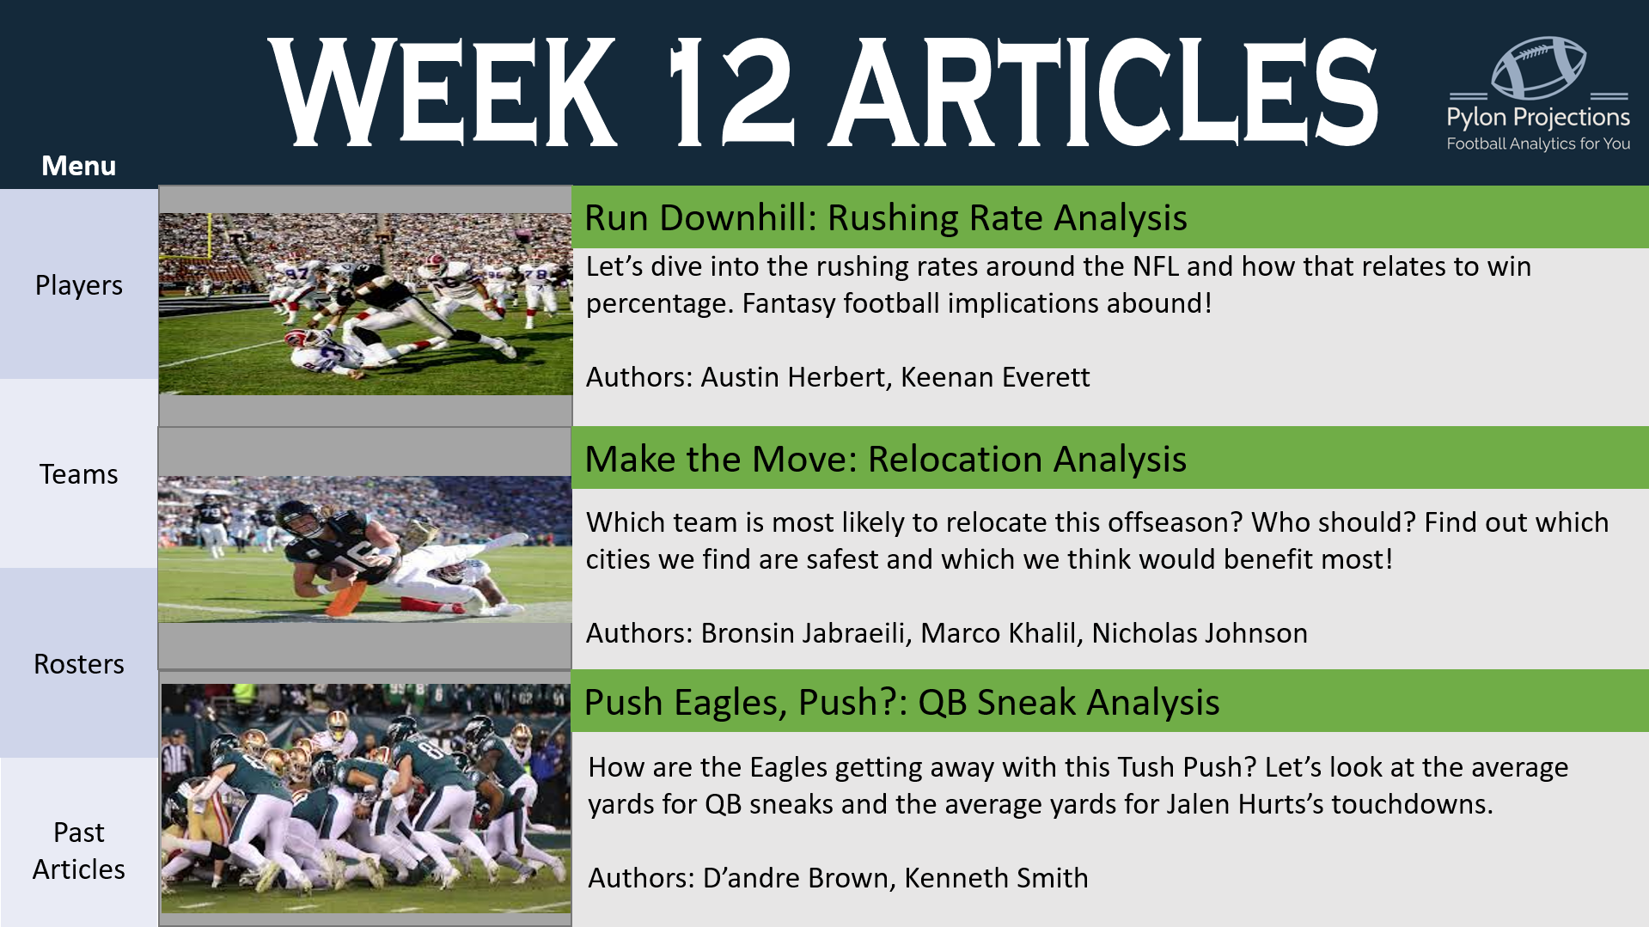
This website can serve as a basis to highlight not only articles like our relocation analysis seen in the middle, but also overall football analytics. The objective of the website is to be a one stop shop for articles, code, and player/team statistics. Focusing a website solely on relocation would likely be too specific and limit traffic (“clicks”), however, tags on the articles such as “relocation” can be used so the user can stay up to date on their preferred topical trends and insights.

Appendix
Relocation Scores for Each NFL Franchise
Team | Relocation Score
Dallas Cowboys | 488.8954
Las Vegas Raiders | 336.405
Tampa Bay Buccaneers | 301.3294
Los Angeles Rams | 299.2445
New England Patriots | 294.2231
New York Giants | 273.3928
Green Bay Packers | 272.5962
San Francisco 49ers | 267.2965
Denver Broncos | 259.7593
Philadelphia Eagles | 257.5683
Miami Dolphins | 256.6912
Chicago Bears | 255.3507
Kansas City Chiefs | 252.9836
Seattle Seahawks | 249.7077
Pittsburgh Steelers | 247.0176
New Orleans Saints | 245.1457
Los Angeles Chargers | 243.8051
Cleveland Browns | 240.8979
Baltimore Ravens | 240.2321
Carolina Panthers | 237.7842
Minnesota Vikings | 235.2048
Washington Commanders | 234.7058
Tennessee Titans | 230.275
Arizona Cardinals | 227.8984
Buffalo Bills | 227.8293
Atlanta Falcons | 222.8977
Houston Texans | 219.7882
Indianapolis Colts | 217.9816
New York Jets | 214.612
Jacksonville Jaguars | 212.426
Cincinnati Bengals | 203.6484
Detroit Lions | 198.9832

